**Simultaneous Confidence Interval Methods for Analytical Similarity Assessment**

**Donglei Yin**

Department of Applied Mathematics and Statistics, Stony Brook University

**Mentors**: Drs. Shein-Chung Chow, Mengdie Yuan

**Abstract**

Analytical similarity assessment is the foundation of the development of biosimilar drug product, where the quality attributes to characterize the test product and the reference product needs to be shown statistically similar. When there were multiple references, e.g., a US-licensed reference product and a EU-approved reference, in addition to the similarity of the test product with each of the reference product, extra evidence for the similarity between the two reference products is also needed in the analytical similarity assessment. The method of pairwise comparisons has been widely used, but is recently criticized due to the lack of accuracy and reliability of each pairwise comparison since each comparison does not fully utilize all data collected from the three groups. In addition, since the equivalence criterion for analytical similarity is based on the variability of reference product, the pairwise method therefore uses different equivalence criteria in the three comparisons. To avoid these issues, we proposed an alternative method using simultaneous confidence approach based on the fiducial inference theory. Scenarios with and without the assumption of equal variance between the three products were discussed. For each scenario, three versions of simultaneous confidence approach were proposed based on the different assumptions of the population variance, and within each version, two types of simultaneous confidence interval were proposed. We then conducted extensive simulation studies to compare the performance of our proposed method and the pairwise method, and provided examples where the pairwise comparison approach failed but the simultaneous confidence approach passed to illustrate the concern of using pairwise method. The simulation result shows that the first two proposed simultaneous confidence interval approaches have significant larger power compared to the pairwise comparison method as controlling the type one error within a reasonable level, and the superiority maintains as the standard deviance varies. While the third proposed approach demonstrates the smallest power among the four methods, thus is more conservative and will only be recommended in scenarios where controlling type one error was more urgent concern.

**Keywords:** biosimilarity; multiple reference; simultaneous confidence interval; fiducial inference

**Preliminary simulation result:**

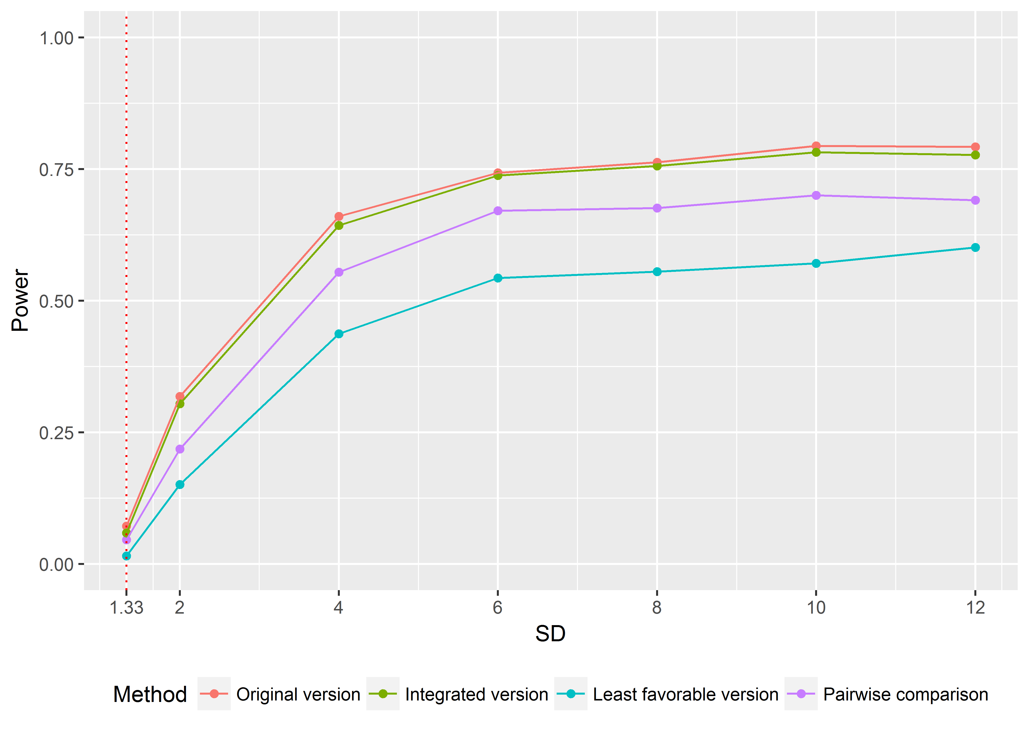

**Figure 1. Simulation performance of different methods (equal variance scenario).** The purple line represents the pairwise comparison, and the rest three lines represents the three versions of simultaneous confidence interval approach (original, integrated and least favorable version). The x-axis represents the sample standard deviation which takes values from 1.33 to 12, where the red-dotted line (SD=1.33) is the rejection margin under EAC. The y-axis represents the empirical power based on 1000 replications. Sample means for the two reference drugs and the test drug were set to be: $μ_{R_{1}}=99, μ_{R_{2}}=101, μ_{T}=100.$ Sample size $n_{R_{1}}= n_{R_{2}}=n_{T}=10$. Type one error was controlled to be under 0.1. The figure indicates that the original (orange line) and integrated (green) version of simultaneous confidence interval approach have significantly larger power than the pairwise comparison (purple), and the superiority maintains as the standard deviance varies. While the least favorable version (blue) performs the worst among the four methods.